Crosswinds Facility Request Form

Please fill out this form and return it to the church office 30 days in advance of the requested event date. If you received this form electronically, you may fill it out using MS Word typing in the shaded areas. Email the completed form to alanna@crosswinds.church

1. General Information

Event Title: _____________________________________ Requestor’s Name: ________________________________
Event Date: _____________________________________ Requestor’s Phone Number: _________________________
Event Start & Finish Times: ___________ to ___________ Requestor’s Email: _________________________________
Event Day of the Week: ____________________________ Number of Guests Expected: _________________________
*Security is needed if the event is over 50 people*
When do you need to have set-up completed? __________
What time do you need to get in to prepare? ____________
Do you need a key to the facility? Yes ______ No _______

Multiple/Recurring Dates & Times: _____________________________________________________________________

If you represent an outside organization, you MUST submit a Certificate of Liability Insurance with this form.

2. Rooms Please check all needed:

Ministry Center/ Lobby _____ The Box/ Box Kitchen _____ K-2 Theater _____
Chapel _____ The Box Stage _____ K- 2 Rooms: 1 ___ 2 ___ 3 ___
Kitchen _____ Chickadees _____
Coffee Shop Lobby _____ Lambs _____ 3-5 Theater (no stage) _____
Office Lounge _____ Cubs _____ 3-5 Rooms: 1 ___ 2 ___ 3 ___
Conference Room _____ Otters _____ 4 ___ 5 ___ 6 ___
Atrium Upper & Lower _____ Children’s Lobby _____ *ALL Kids Ministry Rooms need to remain NUT-FREE*

Athletic Field _____ *there are no restrooms available on the field Pavillion _____

3. General Equipment Please write in quantities needed:

8’ Rectangular Table _____ Whiteboard _____ Other: ___________________________
6’ Rectangular Table _____ Podium _____
5’ Round Table _____ Easel _____
Chairs _____ Roku TV Cart _____

4. Technical Support Needed Yes ____ No ____
*If a technician is needed, please attach a program schedule to this form. Also, there may be a cost incurred with tech support.

Contact person: ______________________ Phone: ___________________Email: ___________________________
(Person who can discuss technical needs)

a. Please indicate the number of each item needed:
Wireless, Hands-free microphone _________ Wireless, Hand-held microphone ________ Podium, microphone ______

b. Media Sources Being Used:
DVD/BlueBay______ Presentation (Video/Graphics) ______ Song lyrics _____ (displayed on screen) Image slideshow _____

5. Room Set-up Diagrams On the back of this sheet, show arrangements of tables, chairs, and any other equipment
requested.

***Conduct on the campus should be in keeping with Christian norms. The use of alcoholic beverages, tobacco,
drugs of any kind (other than prescribed medication), the use of profanity, music and other materials with offensive
language/content are strictly prohibited anywhere on the CWC campus. Any violation of this guideline will be
cause for immediate termination of the event.***

Church Office Use Only:
Date Form was submitted ___________ Placed on Calendar __________ Signature _______________________

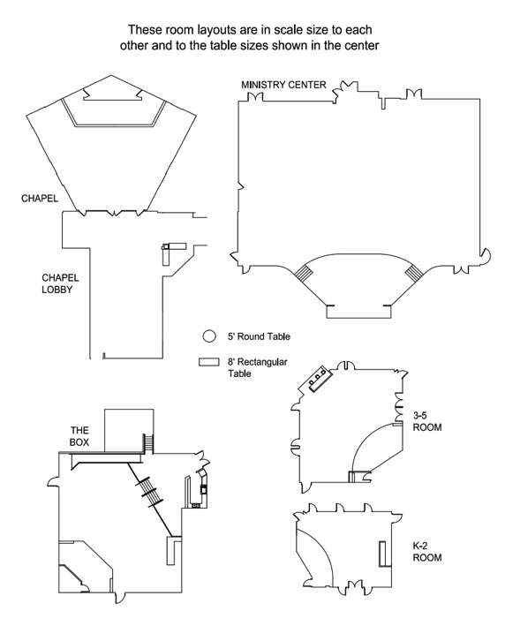
3360 Middle Cheshire Road, Canandaigua, NY 14424 – P 585.394.5857 – F 585.394.6642 – crosswinds.church

140
Normal
Capacity
150
Normal
Capacity
540
Normal
Capacity
50
Normal
Capacity
70
Normal
Capacity

